
Test 5
Continuous Random Variables
The Normal Disribution
Sample Proportions

Semester Two 2018
Year 12 Mathematics Methods
Calculator Assumed

Name:
Teacher:

Mr McClelland

Miss Berry

Mr Gannon

Ms Cheng

Mr Staffe

Mr Strain

Date: Fri 17th Aug. 7:45am

You may have a formula sheet for this section of the test.
Classpad Calculators
1 page of Notes

Total___________/47 50 minutes

Question 1 (5 marks)
The life of an electronic component is given by the probability density function:
f(x) =
Find:
(a) the probability that a component lasts for more than 250 hours. (2 marks)

(b) the median life of a component. (2 marks)

(c) the lifetime for 95% of components. (1 mark)

Question 2 (4 marks)
(a) Pr(Z < –0.376), where Z is a standard normal random variable is: (1 mark)

(b) If Z is a standard normal random variable, and Pr(Z > c) = 0.75, then the value of c is? (1 mark)

(c) If X is a normally distributed random variable with mean μ = 4 and standard deviation,
σ = √2, then the transformation that maps the curve of the density function of X, f(x), to the curve of the standard normal distribution is: (2 marks)

Question 3 (2 marks)
The weight of a population of teenage females is normally distributed with a mean of 55 kg and a standard deviation of 8 kg. If the lowest 5% of teenage females is classified as underweight, what is the cut-off weight for this group?

Question 4 (6 marks)
A probability density function is given by

f(x) = Ax(6 – x)² 0 < x < 6

Find the value of A and hence the mean and the standard deviation of this distribution.

Question 5 (10 marks)
A taxi company determined that on an annual basis the distance travelled per taxi is normally distributed with a mean of 92 000 kilometres and a standard deviation of 23 500 kilometres.
(a) What is the probability, correct to four decimal places, that a taxi travels less than 75 000 kilometres per year?

(b) What is the probability, correct to four decimal places, that a taxi travels more than
80 000 kilometres per year?

(c) What is the probability, correct to four decimal places, that a taxi travels between 60 000 and 100 000 kilometres in the year?

(d) Find the minimum mileage that could be expected by 95% of taxis, to the nearest km.

(e) Fred runs a fleet of 10 taxis. What is the probability that at least four of the taxis travel more than 80 000 kilometres in a year?

Question 6 (1 marks)
A bag contains 4 black balls and three blue balls. If a random sample of four balls is taken from the bag, without replacement, the possible values of the sample proportion of blue balls in the sample are:

Question 7 (9 marks)
A random sample of 100 people indicated that 19% had taken a plane flight in the last year.
(a) Determine a 90% confidence interval for the proportion of the population that had taken a plane flight in the last year. (3 marks)

Assume the 19% sample proportion applies to the whole population.
(b) A new sample of 200 people was taken and X= the number of people who had taken a plane flight in the last year was recorded. Give a range, using the 90% confidence internal, within which you would expect X to lie. (1 mark)

(c) Determine the probability that in a random sample of 120 people, the number who had taken a plane flight in the last year was greater than 26. (3 marks)

(d) If seven surveys were taken and for each a 95% confidence interval for p was calculated, determine the probability that at least four of the intervals included the true value of p. (2 marks)

Question 8 (10 marks)
A random survey was conducted to estimate then proportion of mobile phone users who favoured standard smart phones over the new phablet style smart phones. It was found that 283 out of 412 people surveyed preferred the new phablet style smart phones.
(a) Determine the sample proportion  of those in the survey who preferred a phablet style smart phone. (1 mark)

(b) Use the survey results to estimate the standard deviation of , for the sample proportions. (2 marks)

(c) A follow – up survey is to be conducted to confirm the results of the initial survey. Working with a confidence interval of 95%, estimate the sample size necessary to ensure margin of error of at most 4%. (3 marks)

The 90% confidence interval of the sample proportion , from the initial survey is 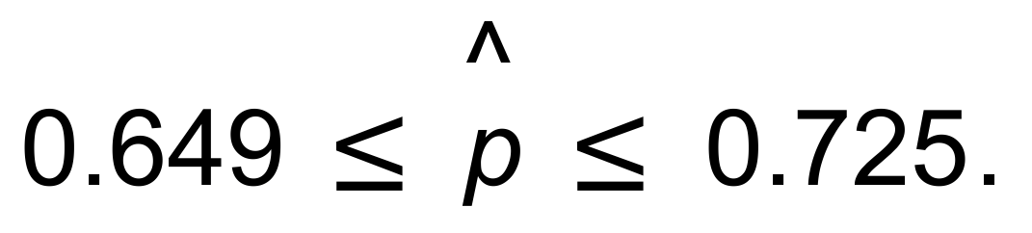
(d) Use the 90% confidence interval of the initial sample to compare the following samples:
(i) A random sample of 365 people at a shopping centre found that 258 had a preference for the phablet style smart phone. (2 marks)

(ii) A random sample of 78 people at a retirement village for Maths teachers 52 had a preference for the phablet style smart phone. (2 marks)

